**NSCI 20100 Neuroscience Laboratory**

**Reaction Time**

**BSLC 322, January 15-17, 2020**

**Goals:** In this lab, you will use electro-oculogram (EOG) signals to measure saccadic reaction times. With these data, you will examine the effects of different stimulus conditions on those reaction times. In performing the measurements, you will gain experience with amplifying, filtering and processing microvolt analog signals.

**Reading:** Before the lab, you should read overview material by Carpenter (1988) and Collewijn (1999), which you will find on the Canvas site. If you are interested in reading research results from one of the earliest applications, you might look at the following article, which is also on the site:

Fenn, W.O. and Hursh, J.B. (1934) Movements of the eyes when the lids are closed. *American Journal of Physiology*, 118:8-14.

**Safety:** There is alcohol in skin preparation pads for cleaning the skin before placing the EOG electrodes. Do not let any liquid from the pads get in your eyes. Once the EOG electrodes are installed, keep the leads protected and away from water and electrical sources until they are inserted into the isolation unit. No personal protective equipment (PPE) is required or recommended.

**Data:** You will collect eye position traces for saccades under three different stimulus conditions. You should collect data separately from both students in each lab team (complete data collection from the first before beginning the second). Clean the EOG electrodes between subjects as described in the procedures.

**Clean up:** When you have finished, you should clean the EOG electrodes as described in the procedures. Quit Matlab and collect any data files from the lab machine. You do not need to log out, reboot or shutdown the computer. Disconnect the electrical equipment so it is in the state in which you found it.

**Lab Report:** Lab reports should be prepared following the general instructions found on the course Canvas site. In preparing your report, you should consider the following:

*Results:* Include in your report one or more figures summarizing your data. Are there meaningful differences between the reaction times for the different conditions? Use the appropriate confidence interval(s) to support any conclusions about the data.

*Discussion:* What do your data suggest about interactions between fixation and saccadic eye movements? What can you draw conclusions about parallel brain mechanisms controlling movements of the eyes?

**Laboratory Procedures**

***Hardware:***

*Recording Equipment:* The hardware and cabling will need to be set up. Configure the electronics before turning on the amplifier. The small switch on the C-ISO-256 pre-amplifier must be set to 2.5 kHz. The cable from the C-ISO-256 should be connected to left input of the iWorx ETH-256 amplifier. The initial settings for Channel 1 on the iWorx amplifier should be: “DC” HPF (high-pass filter; DC is direct current, or 0 Hz, i.e., no high-pass filtering); “50 Hz” LPF (low-pass filter); and “x10” gain. The iWorx C-ISO-256 pre-amplifier has a fixed internal gain of 400x. The settings on the amplifier are indicated by small red LEDs and are changed by pressing the appropriate black button. You may change these setting to improve the quality of your data, but they should be fixed during data collection from each subject (and included in your lab report). Your calculation of EOG voltage must include the combined amplification of the amplifier (10x typically) and pre-amplifier (fixed at 400x). You will not be using Channel 2.

Use a BNC cable to connect Output 1 of the ETH-256 to a LabJack U6 computer data acquisition unit. A BNC-to-wire adaptor will need to be installed to the LabJack’s analog input channel 0 (AIN0, red wire) and analog ground (GND, black wire) inputs. The wires must be inserted above the silver tab in the slot and tightened by turning the screw clockwise. The LabJack U6 should be connected to the iMac computer with a USB cable.

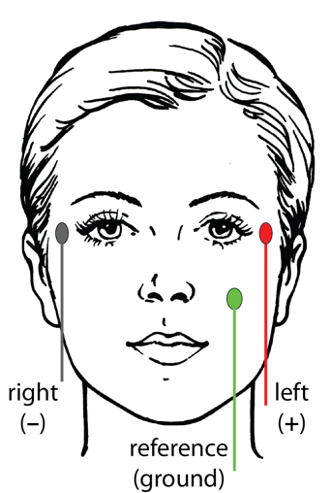*EOG Electrodes*: You will record the EOG using three electrodes. Two active electrodes are positioned immediately lateral to the eyes, but not so close that they interfere with blinking. The remaining reference electrode should be placed on the left check immediately below the eye.

Use an electrode prep pad to gently clean the skin at three sites. Avoid getting alcohol from the pad in your eyes. Allow the skin to dry completely before attaching the electrodes.

To attach each electrode, lift the blue tab on one sticky pad to pull it and its paper face from backing. Attach the sticky side of the pad to the electrode face. Remove the outer protective paper from the sticky pad and press the pad and electrode on the skin with the wire oriented downward. Once gentle pressure has been applied, the electrode should remain attached. Drape the wire over your shoulder or put it in a shirt pocket to keep it from getting pulled. Attach the remaining two electrodes. Insert a small amount of electrolyte gel inside the electrode using the syringe and blunt needle. Pass the blunt needle through the hole in the electrode and gentle push the plunger until gel starts to come out of the top of the hole.

Plug the electrodes into the C-ISO-256 isolation unit. The jacks are color coded according to the diagram above (red-left, black-right, green-reference). It does not matter if the electrodes you have are different colors, but you should connect them according to this color coding.

***Software:***

You will use Matlab applications to collect your data. The necessary software is installed and configured on each of the lab’s computers. Use the following procedures to run the software.

1) Log into the “labuser” account. There is no password for this account; it should not ask for one. If it does request a password, leave that field blank.

2) Launch Matlab by clicking on the Matlab icon in the dock at the bottom of the display. (Matlab might have a date appended to its name, such as “Matlab_2019b”.)

You will be using two applications in the lab: Oscilloscope and SaccadeRT. You must not run them simultaneously. Matlab will let you do this, but it will generate hardware issues. Quit one application before starting the other. You do not need to quit Matlab to go between the applications.

***Signal Assessment:*** Before attempting to collect data, you will use the Oscilloscope application to assess the quality of your signal. You want to see little 60 Hz noise (16.7 ms period) and clear upward and downward deflections of the voltage trace when making large leftward and rightward saccades. You should strive for 60 Hz noise of <50 µV (pre-amplification). You should also familiarize yourself with the way that clenching your teeth or blinking affects your EOGs.

3) When it launches, Matlab will display a large, multi-paneled window. You will first measure your 60 Hz noise using an application called “Oscilloscope”, which you can launch by typing its name in the Matlab “Command Window” at the bottom of the Matlab window.

4) The Oscilloscope application will take several seconds to launch. Once it has finished launching, you will see a new window as shown below. When you press the **Start** button, it should begin display the analog signal from the EOG electrodes. You should use this display to minimize the 60 Hz noise (16.7 ms period) on the signal. Large saccades to the left or right should produce vertical deflections that are much larger than any noise. If you are wearing the electrodes, you can see the signal by holding your gaze fixed on the display window while rapidly rotating your head to the left and right (thereby changes the position of your eyes in their orbits.

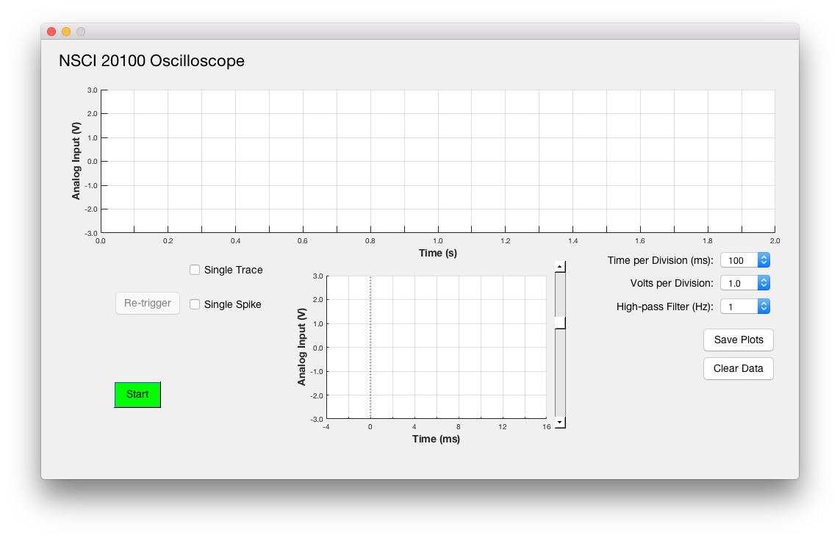

5) When you are satisfied with your signal, you can terminate the Oscilloscope application by closing the EOG control panel window using its close button (red button in the upper left corner). Leave Matlab running. You will need it for collecting data.

***Running the SaccadeRT***

Launch the SaccadeRT application by typing its name in the Matlab command window. It will take several seconds to launch. Once the SaccadeRT application has finished launching, you will see two new windows, which are described below.

../../Screen%20Shot%202017-12-11%20at%2018.30.33.png

The stimulus display will appear as a long, thin horizontal dark gray window at the bottom of the monitor. The control/display panel will appear above and to the right. You should familiarize yourself with the controls and displays and run test trials before you start collecting data you plan to use. You can clear any test data before you start any serious data collection.

The task involves following the small white dot with your eyes. At regular intervals, the white dot will jump left or right at random by 5°. You should simply do your best to keep your gaze on the dot. You should shift your gaze to follow the dot as quickly as you can after it moves. It is important that you do not look away from the dot while you are collecting data. For this reason, you will want to pause and restart your data collection frequently so that you can take breaks. However, you should pause the task before you stop looking at the dot.

**Settings:** Before collecting data, you must adjust the task settings. You must enter the **Viewing Distance**. To set the viewing distance, find a comfortable viewing position and measure the approximate distance from your eyes to the screen. This should generally be 50 to 75 cm. You must enter this value before data collection to ensure that the stimulus steps are calibrated.

The application has a digital notch filter that will remove frequencies close to 60 Hz from the eye position velocity traces. You will typically get better data with this filter turned on (using the **Filter 60 Hz** checkbox).

You should adjust the **Saccade Threshold** so that you reliably detect most of the saccades without allowing fluctuations in the noise to be counted as saccades. It is better to miss some saccades than to include spurious signal fluctuations as saccade.

**Saccade Detection:** The application finds saccades using the following approach. A saccade is detected when the position trace first crosses the **Saccade Threshold** after the stimulus step. Five consecutive values (sampled at 1 kHz) above the threshold are counted as the start of a saccade. (If too few trials have been run for the application to establish a calibration, it will assume that the maximum voltage in the trace corresponds to the stimulus step size on that trial.) When the threshold is crossed, the application will search back in time from the first sample above threshold to the point where the velocity became positive (relative to the direction of the saccade), and count that as the start of the saccade. It will then search forward in time to the first position maximum, and count that as the end of the saccade. The start and end of a detected saccade are marked with vertical dotted lines in the most recent position and velocity traces (the two plots to the left in the window). These will not appear when no saccade is detected. The time of the stimulus step is marked with vertical the dash-dotted line these plots.

As the fixation spot steps proceed, three different stimulus conditions will be randomly interleaved: gap, step and overlap. In the step condition, the fixation point simply disappears from one position and reappears at another. In the gap condition, the fixation point disappears and reappears at a new position after a 200 ms gap. In the overlap condition, the spot appears at its new location 200 ms before it is turned off at the old position.

Reaction times will be plotted in the three right plots, one for each condition. Once enough trials have been collected, these plots will display the distribution SD, SEM and 95% CI. These are shown graphically above the distributions (SD on top, 95%CI on bottom).

**Breaks**: While you do the task, you should take frequent breaks, but you should not leave the task running when you pause. You should be tracking the spot with your eyes whenever the task is running. You can use the **Start/Stop** button to toggle the task run state. For convenience, you can also use the space bar to toggle the run state if the control panel is front-most. This allows you to pause the task without looking at the mouse or Start/Stop button on control panel. If you are distracted by the plots updating, you should move that window so that the plot are offscreen.

**Controlling the EOG Task**

The following controls are found at the bottom left of the Control Panel.

**Start (Stop):** Toggles whether the task is running. You can also use the space bar when the control window is front-most.

**Viewing Distance (cm):** The distance from your eyes to the screen. This value must be set before data collection to ensure that your position and speed measures are properly calibrated.

**Saccade Threshold (deg):** The program detects the start and end of each saccade using a movement threshold. You can adjust that threshold here. If your filtered trace is noisy, you will need to set the threshold higher to avoid spurious detections. If your filtered traces are less noisy, you can set the threshold lower to get more precise measurements of the saccade dynamics. The threshold level appears as a horizontal blue line in the plot labeled “Most recent position trace”.

**Clear Data:** This button can be used to discard the current data. You should save any data you care about before clearing

**Save Plot:** This button will allow you to save a PDF file with the current contents of the display plots. This is useful for getting figures you can use in your lab report.

**Save Data:** This button will allow you to save your data in a Matlab ‘mat’ file. Save data can be reloaded using the “Load Data” button.

**Load Data:** This button will allow you to load data you have previously saved using the Save Data button. Note that any loaded data will overwrite current data, causing it to be lost.

The following displays are plotted in the control/display panel:

**Most Recent Position Trace:** The most recent position trace is displayed. The difference between the two EOG electrodes is plotted as a function of time. Rightward and leftward eye movements correspond to up (positive) and down (negative) on this and other displays. A dotted-dashed line marks the stimulus movement. The target onset will be marked with a vertical dash-dotted line. The fixation offset will be marked with a red vertical dash-dotted line, and might appear before (gap) or after (overlap) the target onset. On step trials no fixation offset line will appear (it is the same as target onset). If a saccade is detected, its duration will be marked by vertical lines. Traces are offset vertically so that the average of the pre-movement portion of the trace lies at y = 0 V (0°).

**Most Recent Velocity Trace:** The most recent velocity trace is displayed. This curve is the derivative of the most recent position trace plotted in Most Recent Position Trace. Calibration is in V/s until enough traces have been collected to establish a voltage-to-position calibration, after which it is plotted in units of deg/s. Other formatting follows that for the most recent position trace.

**Clean up:** When you have finished collecting and saved your data, you can terminate the SaccadeRT application by either 1) closing the SaccadeRT control panel window using its close button (red button in the upper left corner), 2) closing the Matlab window using its close button, or 3) making Matlab quit using Quit in the File Menu (or the keyboard equivalent, command-Q). In any case, you will be asked whether you are sure you want to quit. All unsaved data will be lost when you quit.

Immediately after removing the EOG electrodes, wash out the gel or cream using distilled or deionized water. Do not use tap water. A cotton swab can be used to remove the main bulk of the gel or cream. Do not scratch the metal surface of the electrode. You can remove any gel from your face with a wet paper towel.